**Art Show and Benefit for:**

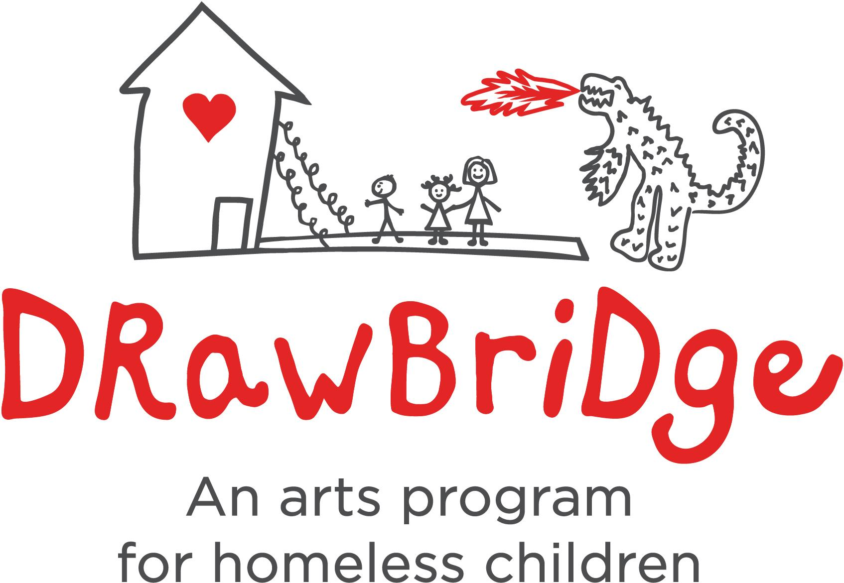

**Sunday July 23 / 2017 1:00 -5:00 pm**

**TROUVÉ Gallery Garden**

**• 51 BOLINAS ROAD, FAIRFAX, CA 94930 •**

Featuring:

**ART ON CERAMIC TILE**

Justine Tot Tatarsky <http://www.artontile.com/>

**Multi-Metal SCULPTURAL JEWELRY**

Rachel Levy-Bencheton

<https://www.rachellevybenchetonstudio.com/>

**Multi-Instrumental SINGER SONGWRITERS**

Sara Gallagher & Jacob Aranda [www.jacobaranda.com](http://www.jacobaranda.com)

*30% of all sales and tips will be donated to [DrawBridge](http://www.drawbridge.org/) art programs for kids